**Name:Muhammad Hamza Khan**

**Roll No: 21L5654**

**CN-LAB05**

**Question 1:**

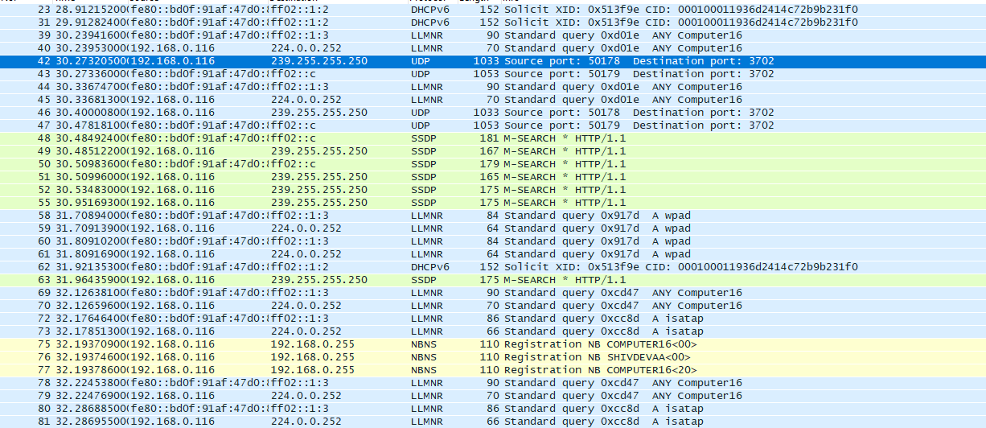

**Question 2:**

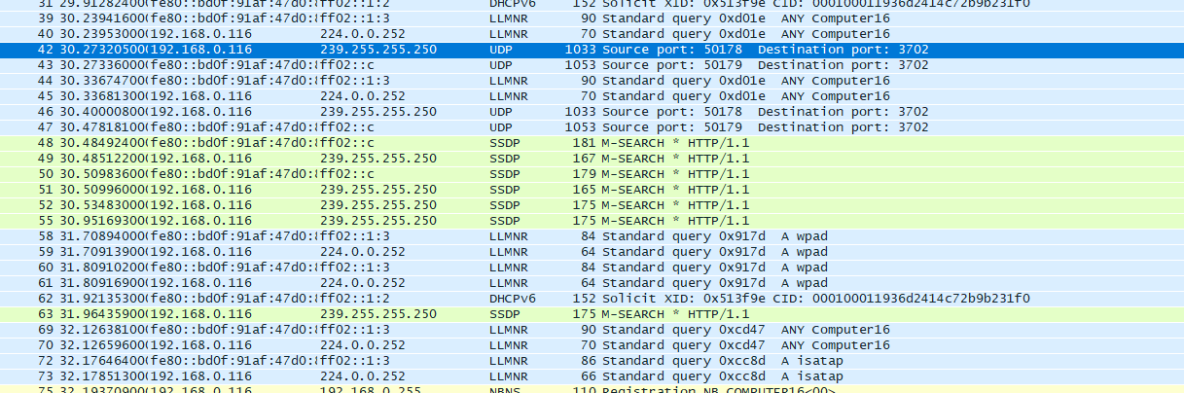

**Packet 42:**

* Source IP: 192.168.0.116
* Destination IP: 239.255.255.250
* Port: UDP 1033
* Source port: 50178
* Destination port: 3702

**Packet 43:**

Source IP: fe80::bd0f:91af:47d0:ff02

Destination IP: ff02::c

Port: UDP 1053

Source port: 50179

Destination port: 3702

Brief explanation:

The 192.168.0.116 is private IP,239.255.255.250 is local network,fe80::bd0f:91af:47d0:ff02 is an IPv6 link-local address.,ff02::c is an IPv6 multicast address.

These packets are communication protocols.

**Question 3.**

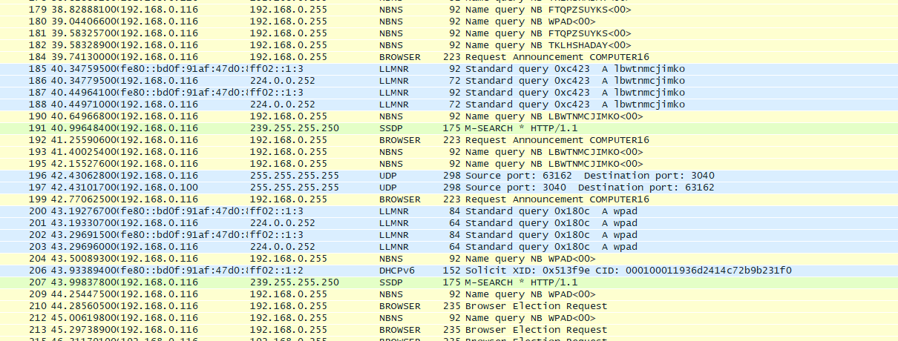

**Packet 196:**

Source IP: 192.168.0.116

Destination IP: 255.255.255.255

Protocol: UDP

Source port: 63162

Destination port: 3040

**Packet 197:**

Source IP: 192.168.0.100

Destination IP: 255.255.255.255

Protocol: UDP

Source port: 3040

Destination port: 63162

Explanation of destination IP address 255.255.255.255 is the broadcast IP address. When a packet is sent to this address, used for network discovery or when a device needs to communicate with all other devices on the network without knowing their specific IP addresses.

**Q4.**



Broadcast, Multicast, and Link-Local Addresses

Broadcast (255.255.255.255), multicast (239.255.255.250), and link-local IPv6 addresses enable local network discovery, service announcements, and communication without routing to the internet. They support protocols like SSDP and IPv4/IPv6 coexistence during the transition to IPv6.These types of addresses are crucial for automatic configuration, service discovery, and efficient local network communication without requiring manual configuration of each device's IP address.